**THE NYERI NATIONAL POLYTECHNIC**

**TRADE PROJECT**

**TECHNICAL BLOGGING SYSTEM**

**COURSE**: DIPLOMA IN IFORMATION COMMUNICATION TECHNOLOGY

**PRESENTED BY:** MARTIN MURITHI WACHIRA

**INDEX NUMBER:** 2020010255

**SUPERVISRD BY:** MADAM KABURU

**EXAM SERIES:** NOVEMBER 2023

# DECLARATION

I Martin Murithi Wachira of index 2020010255 declare that this is my work original work and has not been presented in any other college or any other institution of higher learning for examination purposes.

I therefore submit this project with the approval of my supervisor.

_________________ ___________________

Madam Kaburu Signature and Date

(Supervisor)

# ACKNOWLEDGEMENT

I would like to express my heartfelt gratitude to the Almighty for guiding me throughout this research journey. I extend my sincere appreciation to my dedicated supervisor, Madam Kaburu, for her invaluable guidance and support during both my study and project development phases. I am also deeply thankful for the unwavering support I have received from my family, friends, lecturers, and supportive classmates. Their encouragement and assistance have been instrumental in helping me successfully complete this project.

# ABSTRACT

Blogr.io is a dynamic web application tailored to meet the needs of the ever-evolving technology enthusiast community. This innovative platform empowers users to share their wealth of knowledge, experiences, and insights within the realm of technology through various content formats, including tutorials, reviews, and blogs. What sets Blogr.io apart is its user-centric approach, enabling individuals to effortlessly create accounts using their email addresses. This streamlined onboarding process fosters active participation and knowledge exchange, fostering a vibrant technology community.

Blogr.io serves as a central hub where diverse technology backgrounds converge to contribute expertise and engage with like-minded individuals. In an era of rapid technological advancements, accessing accurate and up-to-date information can be challenging. Blogr.io addresses this by consolidating valuable knowledge within a single platform, simplifying information gathering for technology enthusiasts and promoting a more informed and empowered community.

A key challenge that Blogr.io addresses is the fragmentation of technology-related content across the internet. With the technoloy’s industry's breakneck pace, enthusiasts often find themselves searching multiple sources for information. Blogr.io tackles this issue head-on by centralizing knowledge, making it easily accessible in one place. This approach streamlines the information-seeking process and contributes to a more cohesive and knowledgeable technology community.

Table of Contents

DECLARATION 2

ACKNOWLEDGEMENT 3

ABSTRACT 4

CHAPTER ONE 7

1.0 Project Overview 7

1.1 Problem Statement 7

1.1.1 The Problem 7

1.1.2 Importance of solving the problem 7

1.2 Research Questions 7

1.3 Scope 8

1.4 Target Audience 9

1.4.1 Primary Audience 9

1.4.2 How the targeted audience is catered for 9

CHAPTER TWO 10

2.0 LITERATURE REVIEW 10

2.1 Overview of Technology Enthusiasts Communities 10

2.1.1 The Importance of Technology Enthusiast Communities 11

2.1.2 Role in Knowledge Sharing, Collaboration, and Networking 11

2.2 Historical Perspective of Article Writing in Technology 11

2.3 Review and Comparison of Similar Platforms 13

2.4 Lessons for Blogr.io's Development 15

2.5 Concepts and Theories 16

2.5.1 Relevant Concepts and Theories 16

2.5.2 How the concepts and theories apply to Tech Communities 16

2.5.3 Examples of how these theories and concepts have been utilized 17

2.6 User engagement and Participation 17

2.6.1 User engagement strategies used by tech communities 17

2.6.2 Factors influencing user participation 17

2.6.3 How Active and Engaged Users Contribute to the Success of These Communities 18

2.7 Evolving Trends in knowledge sharing 19

2.7.1 Examining Evolving Trends in Knowledge sharing 19

2.7.2 Change in content formats 19

2.7.3 How Artificial Intelligence is influencing knowledge sharing practices 20

CHAPTER THREE 20

3.0 METHODOLOGY 20

3.1 Project Planning 21

3.1.1 Objectives of Blogr.io 21

3.1.2 Project Scope for Blogr.io 22

3.1.3 Development Strategies 23

3.2 Requirements Analysis 26

3.2.1. User Needs Assessment 26

3.2.2 User Stories and Use Cases 28

3.2.3 Functional Requirements 32

3.2.4 Use of Personas 34

3.3 Design Phase 35

.3.4 Development Phase 39

3.5 Testing and Quality Assurance 40

3.6 Maintenance 41

CHAPTER FOUR 41

4.0 Findings, Data Analysis, Conclusions and Recommendations 41

4.1 Findings 41

4.1.1 User Engagement Insights 41

4.1.2 Performance Discoveries 41

4.2 Data Analysis 41

4.2.1 User Behavior Patterns 41

4.2.2 Content Analytics 41

4.3 Conclusions 42

4.3.1 Platform Successes 42

4.3.2 Challenges Acknowledged 42

4.4 Recommendations 42

4.4.1 Feature Enhancement 42

4.4.2 User Retention Strategies 42

4.4.3 Content Promotion 42

4.4.4 Future Expansion 42

References 43

PROJECT SCREENSHOTS 43

# 

# CHAPTER ONE

### 1.0 Project Overview

Blogr.io is a user-friendly web application designed for the tech-savvy community, enabling easy knowledge sharing through various content formats like tutorials, reviews, and blogs. Its streamlined onboarding process simplifies account creation using an email address, fostering active participation within the tech community. It serves as a vital hub where technology enthusiasts from diverse backgrounds converge to share expertise and stay updated in the rapidly evolving technology world.

## 1.1 Problem Statement

### 1.1.1 The Problem

In today's fast-paced technology world, staying updated and finding reliable, up-to-date technology information can be challenging. Technology enthusiasts often struggle to locate trustworthy sources for tutorials, honest product reviews, and insightful technology blogs. With information scattered across countless websites and forums, the process of discovering valuable knowledge becomes time-consuming and frustrating.

### 1.1.2 Importance of solving the problem

Addressing this challenge is important as the technology community relies heavily on accurate information and insights. Accurate technology knowledge is not just a luxury; it's the lifeblood of innovation and informed decision-making. A reliable platform like Blogr.io that centralizes technology-related content and encourages knowledge sharing not only simplifies the information-seeking process but also empowers individuals within the technology community. It nurtures an environment where enthusiasts can readily access credible content, exchange experiences, and foster collaborative learning.

## 1.2 Research Questions

**(a) How does Blogr.io impact the knowledge-sharing habits of technology enthusiasts?**

This research question aims to explore the influence of Blogr.io on the way technology community share and access knowledge within the platform.

It seeks to understand the platform's role in facilitating knowledge exchange and collaborative learning.

**(b) What are the prevailing content trends on Blogr.io, and how do they reflect the interests of the technology community?**

This question looks into the types of content being created on Blogr.io, such as tutorials, reviews, and blogs, to uncover trends and patterns.

It provides insights into the evolving interests and needs of the technology community.

**(c) How do user behaviours, such as likes, comments, and sharing, contribute to the vibrancy of the Blogr.io community?**

This research objective focuses on user engagement within the platform and its impact on the community's vitality.

It examines how user interactions shape the platform's dynamics and the exchange of knowledge.

**(d) What recommendations and suggestions do users make on Blogr.io, and how do these recommendations influence the platform and its content?**

This question highlights the valuable input from users in the form of recommendations.

It explores the impact of these user-driven suggestions on content quality, community engagement, and the platform's evolution.

## 1.3 Scope

Blogr.io is a full-stack web application that aims to serve the technology enthusiast community by providing a platform for knowledge sharing and interaction. Its scope includes the following key areas:

* **Content Creation**: Blogr.io allows users to create and publish various types of content, including tutorials, reviews, recommendations, and blog posts. Users can contribute their expertise and experiences within the technology field.
* **User Profiles**: Blogr.io caters to a diverse community of technology enthusiasts, including professionals, hobbyists, and learners. It accommodates users from various backgrounds, industries, and skill levels.
* **Knowledge Sharing**: The platform facilitates knowledge exchange and idea sharing among users. It encourages the dissemination of technical information, best practices, and insights within the tech industry.
* **User Engagement**: Blogr.io promotes user engagement through features like liking, commenting, sharing, and following other users. It fosters a sense of community and interaction among members.
* **Community Building**: Blogr.io aims to create a vibrant and supportive community where tech enthusiasts can connect, collaborate on projects, and address industry challenges collectively.
* **Professional and Personal Growth**: Beyond knowledge sharing, Blogr.io provides opportunities for personal and professional development. It encourages skill enhancement, mentorship, and recognition within the technology community.1.4 Target Audience

### 1.4 Primary Audience

The core user base of Blogr.io consists of technology enthusiasts from various backgrounds and expertise levels. This includes software developers, hardware engineers, cybersecurity experts, artificial intelligence researchers, and anyone passionate about technology and its advancements.

### 1.5 How the targeted audience is catered for

Blogr.io is finely tuned to cater to the unique needs and interests of technology enthusiasts in the following ways:

* Content Variety: The platform offers a diverse range of content formats, including tutorials, reviews, and blogs, to accommodate varying preferences and learning styles within the technology community.
* Knowledge Exchange: Blogr.io fosters an environment where knowledge exchange is at the forefront. It allows users to share their insights, discoveries, and experiences while learning from others, thus addressing the inherent curiosity of technology community.
* Community Building: The platform encourages interaction and collaboration among users. It enables individuals to connect with like-minded individuals, share their knowledge, and build a vibrant community centred around their passion for technology.
* Centralized Information: Blogr.io simplifies the search for reliable and up-to-date technology information by consolidating content in one accessible location. This helps users stay informed and engaged in their respective technology fields.

# CHAPTER TWO

## 2.0 LITERATURE REVIEW

This section explores related studies, platforms, and technologies that inform and influence the creation of Blogr.io. It serves as a foundation for understanding the broader landscape in which Blogr.io operates and the unique contributions it brings to the tech enthusiast community.

## 2.1 Overview of Technology Enthusiasts Communities

Technology communities are online hubs where passionate individuals come together to share knowledge, discuss the latest tech trends, and collaborate on projects.

These communities cover a wide spectrum of technology interests, fostering a culture of learning and mutual support. Members exchange ideas, seek advice, and build connections within the industry. It's not just about technology; it's about the people and their shared enthusiasm.

### 2.1.1 The Importance of Technology Enthusiast Communities

* Vital hubs in the technology industry
* Catalysts for innovation and progress.
* Essential for staying updated in a rapidly evolving technology landscape.

### 2.1.2 Role in Knowledge Sharing, Collaboration, and Networking

* Facilitate knowledge exchange and idea sharing.
* Foster a culture of mutual support and learning.
* Enable collaboration on projects and addressing industry challenges.
* Provide opportunities for professional networking.

## 2.2 Historical Perspective of Article Writing in Technology

The history of article writing on the internet is a complex one, here are the key milestones and authors in the history of online article writing:

**1. Early Internet (1960s - 1980s):**

* In the early days of the internet, it was primarily used for research and communication among academics and researchers.
* Articles were often shared through email and early discussion forums, focusing on technical and academic topics.
* Specific authorship is challenging to attribute as online contributions were often made anonymously or under pseudonyms.

**2. Emergence of Usenet and Bulletin Board Systems (BBS) (Late 1970s - 1990s):**

* Usenet, created in 1979, provided a platform for online discussions and article sharing.
* Early internet pioneers like [Brian Reid](https://en.wikipedia.org/wiki/Brian_Reid_(computer_scientist)) and [Tom Truscott](https://en.wikipedia.org/wiki/Tom_Truscott) played key roles in the development of Usenet.
* Bulletin Board Systems allowed users to post articles and discussions within specific communities.

**3. Development of the World Wide Web (Early 1990s):**

* [Tim Berners-Lee](https://en.wikipedia.org/wiki/Tim_Berners-Lee), a British computer scientist, invented the World Wide Web in 1989.
* Berners-Lee's proposal for the World Wide Web in 1990 laid the groundwork for web articles.
* The first website, [info.cern.ch](https://info.cern.ch/), went online in August 1991.

**4. Rise of Web Browsers and Online Publications (Mid-1990s):**

* Marc Andreessen, co-author of the Mosaic web browser, played a significant role in popularizing the graphical web.
* Online publications and early websites like "Wired Magazine" began publishing articles on technology and digital culture.

**5. Blogging Revolution (Late 1990s - Early 2000s):**

* Jorn Barger is often credited with coining the term "weblog" in 1997, which later became "blog."
* Blogging platforms like Blogger (created by Evan Williams and Meg Hourihan) and LiveJournal (created by Brad Fitzpatrick) made it easier for individuals to write and publish articles online.
* Early bloggers like Justin Hall and Dave Winer helped establish blogging as a new form of online content.

**6. Wikipedia and Crowdsourced Knowledge (Early 2000s):**

* Wikipedia, founded by Jimmy Wales and Larry Sanger in 2001, introduced the concept of collaborative article writing.
* Wikipedia articles are authored and edited by a global community of volunteers.

**7. Growth of Online Media (2000s - Present):**

* Online media outlets like TechCrunch (founded by Michael Arrington), Mashable (founded by Pete Cashmore), and others contributed to the proliferation of technology-related articles.
* Prominent technology authors and journalists include Kara Swisher, Walt Mossberg, and David Pogue.

**8. Emergence of Content Management Systems (CMS) (2000s - Present):**

* CMS platforms like WordPress (created by Matt Mullenweg and Mike Little) empowered millions of individuals and organizations to write and publish articles online.

**9. Social Media and Microblogging (2000s - Present):**

* The advent of platforms like Twitter (founded by Jack Dorsey, Biz Stone, and Evan Williams) led to the rise of microblogging and concise article sharing.

**10. Contemporary Landscape (Present):** - The internet is now a vast ecosystem of articles and content on a wide range of topics, with countless authors and contributors from around the world.

## 2.3 Review and Comparison of Similar Platforms

**1. Medium**

[Medium](https://medium.com/) is a widely recognized blogging platform that has gained popularity for its sleek design and accessibility. It encourages writers to share their thoughts, insights, and expertise on a variety of topics, including technology.

**Purpose:** Medium's primary purpose is to provide a platform where writers can publish a diverse range of content. While technology articles are a part of Medium's content mix, the platform does not specialize exclusively in tech-related topics.

**Differentiation from Blogr.io:**

* Medium is known for highlighting individual writers and their personal narratives. It often features personal stories, reflections, and opinion pieces alongside technical content.
* Its scope extends beyond technology, encompassing a wide range of subjects, such as lifestyle, culture, and self-improvement.
* Unlike Blogr.io, Medium does not have a pronounced emphasis on community-driven collaboration or project sharing. It primarily focuses on individual content creation.

**2. Dev.to**

[Dev.to](https://dev.to/), or "The DEV Community," is a specialized platform catering specifically to software developers and technologists. It aims to create a sense of community among developers and provides a space for sharing technical knowledge and experiences.

**Purpose:** Dev.to is purpose-built for the developer community. It serves as a dedicated platform for sharing code snippets, in-depth programming tutorials, and discussions related to software development and technology.

**Differentiation from Blogr.io:**

* Dev.to has a highly focused niche, with a strong emphasis on catering exclusively to developers and their technical interests.
* It is particularly known for its technical discussions, code-sharing capabilities, and hands-on programming tutorials.
* While it encourages community interaction, Dev.to's scope is more specialized compared to the broader range of topics and content formats found on Blogr.io.

## 2.4 Lessons for Blogr.io's Development

1. **Diversity of Content:**
   * Medium’s success highlights the importance of diversifying content. Blogr.io could consider incorporating features that allow users to share not only traditional articles and tutorials but also collaborative projects. This approach will cater to a broader range of technology enthusiasts with varying preferences for content formats.
2. **Community Engagement:**
   * Taking inspiration from Dev.to gamified reputation system, Blogr.io can explore gamification elements such as badges, points, and leaderboards to reward and recognize contributors. By gamifying the user experience, Blogr.io can foster a vibrant and competitive community, encouraging active participation and knowledge sharing.
3. **User-Friendly Onboarding:**
   * Both Medium and Dev.to are known for their user-friendly onboarding processes. Blogr.io should prioritize ensuring a seamless sign-up and content creation experience. An intuitive interface, clear instructions, and user support during onboarding will encourage new users to join and actively participate in the community.

## 2.5 Concepts and Theories

These are concepts and theories that help in understanding how online technology communities work, how content is created and shared within these communities, and what motivates users to engage with the content and each other

### 2.5.1 Relevant Concepts and Theories

* **Community of Practice (CoP):** this is a concept by Jean Lave and Etienne Wenger, emphasizing social learning in a community. In technology enthusiast communities, it highlights how individuals with shared interests and goals collaborate, learn, and develop their expertise collectively.
* **User-Generated Content (UGC)**: this theory underscores the creation of content by users themselves. In technology enthusiast communities, UGC is evident in members generating tutorials, reviews, and discussions, enriching the community's knowledge pool.
* **Social Capital**: Drawing from Pierre Bourdieu's theory, social capital explores the value of social networks and relationships. In technology enthusiast communities, strong social ties can influence knowledge exchange and collaboration.
* **Motivation Theories (e.g., Self-Determination Theory):** These theories delve into what drives individuals to participate in online communities. For technology enthusiasts, intrinsic motivation, such as a passion for technology, often plays a central role in their engagement.

### 2.5.2 How the concepts and theories apply to Tech Communities

* Community of Practice (CoP) in Tech Communities: Technology enthusiast communities exemplify CoP, as members with shared tech interests collaborate, share knowledge, and collectively develop their skills
* User-generated Content (UGC) in Tech information Sharing: Tech enthusiasts actively engage in UGC by creating tutorials, reviews, and discussions, contributing to the collective expertise within the community.
* Social Capital in Tech Networks: In tech communities, social capital manifests through strong social ties, helping members access valuable insights, resources, and collaboration opportunities.
* Motivation in Tech Enthusiast Engagement: Intrinsic motivation, driven by a passion for tech, fuels the engagement of tech enthusiasts in online communities.

## 2.6 User engagement and Participation

### 2.6.1 User engagement strategies used by tech communities

These are methods and techniques that technology communities use to encourage their members to actively participate and engage with the community.

They include:

* Gamification Elements: Many tech communities incorporate gamification elements, such as badges, points, and leaderboards, to incentivize user engagement. These elements encourage users to participate more actively and consistently.
* Content Challenges: Some platforms organize content challenges or competitions, motivating users to create high-quality tutorials, reviews, or projects. These challenges foster a sense of achievement and recognition.
* Community Events: Technology communities often host events like hackathons, webinars, or live Q&A sessions with experts. These events create opportunities for direct engagement and learning.
* Discussion Forums: Forums and discussion boards enable users to ask questions, share knowledge, and engage in ongoing conversations. Active moderation and responsive community managers facilitate engagement.

### 2.6.2 Factors influencing user participation

These factors include:

* Incentives: Offering tangible incentives, such as access to premium content or exclusive features, can boost user participation.
* Community Building: A strong sense of community and belonging is a significant factor. When users feel connected to like-minded individuals and believe their contributions matter, they are more likely to participate actively.
* Quality Content: High-quality, valuable content attracts and retains users. Users are more inclined to engage when they know they can access reliable information or insightful discussions.
* User Recognition: Recognizing and celebrating user contributions, whether through badges, mentions, or awards, fosters a sense of pride and motivates further participation.

## 2.7 Evolving Trends in knowledge sharing

### 2.7.1 Examining Evolving Trends in Knowledge sharing

* Shift to Visual Content: Technology communities are increasingly using visual content formats like video tutorials, infographics, and live streams to convey complex information in a more engaging and accessible manner.
* Interactive Learning: Interactive learning platforms, virtual labs, and gamified tutorials are gaining popularity, allowing users to actively engage with technology concepts.
* Microlearning: Short, bite-sized content is becoming prevalent, catering to the demand for quick, on-the-go learning experiences that fit into busy schedules.
* Crowdsourced Knowledge: Communities are leveraging collective intelligence, with members contributing to a shared knowledge base through wikis, collaborative documents, and open-source projects.

### 2.7.2 Change in content formats

These are the different ways in which technology communities create and present their content

The new content formats include:

* Video Tutorials: Video content, particularly step-by-step tutorials and demonstrations, has become a dominant format for sharing knowledge due to its effectiveness in conveying complex procedures.
* Interactive Guides: Interactive guides, which allow users to actively participate and experiment with concepts, are gaining traction as they facilitate hands-on learning.
* Collaborative Projects: Technology communities are increasingly initiating collaborative coding projects, encouraging members to work together on real-world applications and solutions.

### 2.7.3 How Artificial Intelligence is influencing knowledge sharing practices

This looks at how technological advances, particularly in artificial intelligence (AI) and machine learning, are changing the way knowledge is shared. For example, AI might be used to recommend personalized learning materials to users, or machine learning might be employed to analyze user behavior and improve content delivery.

These are ways in which technological advancements are affecting knowledge sharing practices:

* Personalized Learning: AI-driven algorithms recommend tailored content to users based on their preferences and learning history, enhancing the relevance of knowledge sharing.
* Chatbots and Virtual Assistants: AI-powered chatbots provide instant assistance and answers to user queries, improving the overall user experience and accessibility of information.
* Content Generation: AI-generated content, such as auto-generated code snippets or tech-related articles, is becoming more common, streamlining knowledge creation and dissemination.
* Data Analytics: Machine learning helps analyze user behavior and engagement patterns, enabling platforms to optimize content delivery and user interactions for maximum impact.

# CHAPTER THREE

## 3.0 METHODOLOGY

**Introduction**

This section outlines the critical stages of development, data collection and analysis methods, user-centric design principles, technology stack, and scalability strategies.

## 3.1 Project Planning

### 3.1.1 Objectives of Blogr.io

* **Foster a Thriving Technology Community:** Blogr.io aims to create a vibrant and inclusive community of technology enthusiasts, fostering collaboration, networking, and knowledge sharing among professionals, hobbyists, and learners. It seeks to facilitate meaningful interactions within the industry.
* **Promote Knowledge Sharing:** One of Blogr.io's primary objectives is to encourage the sharing of technical knowledge, insights, and best practices. It serves as a platform where users can publish articles, tutorials, reviews, and recommendations, contributing to the collective understanding of technology trends.
* **Support Personal and Professional Growth:** Blogr.io strives to empower its users by providing opportunities for personal and professional development. It offers mentorship, skill enhancement, and recognition within the community, boosting confidence and leadership skills.

### 3.1.2 Project Scope for Blogr.io

The following functionalities have been added to blogr.io:

**1.Account Creation and Deletion:** The first step is to allow users to securely create their accounts using their email. Additionally, provide them with the option to delete their accounts if needed.

**2. User Authentication:** Implement robust user authentication mechanisms to safeguard user accounts. This includes login and authentication processes using technologies such as jsonwebtokens and protected routes.

**3. Logging in and Logging Out:** Once users have accounts, ensure they can log in and out seamlessly. This is fundamental to user engagement.

**4. Reading, Liking, Commenting, and Saving an article:** Enable users to interact with articles effortlessly. They should be able to read, like, comment on, and save articles for later perusal.

**5. Writing Articles:** Empower users to create, compose, and publish articles. Provide them with a set of text editing tools, image uploading capabilities, and formatting options.

**6. Updating Profile Information:** Allow users to manage and modify their profile information. This includes elements such as profile pictures, biographical details, skills, field of work, location, and contact information.

**8. User Dashboards:** Users should have access to personalized dashboards where they can see insights into their followers, article statistics (e.g., views, likes), and other pertinent information.

**9. Subscribing to Newsletters: U**sers will have an option to subscribe to newsletters. It will be integrated with email services for efficient newsletter delivery.

**10. Password Resetting:** Provide a secure and user-friendly mechanism for resetting passwords to assist users who forget their login credentials.

### 3.1.3 Development Strategies

These are strategies used in the Blogr.io project, focusing on the Waterfall methodology and User-Centred Design (UCD) methodologies.

**a) Waterfall Methodology**

The development strategies are as follows:

**1. Requirements Analysis (Phase 1)**

* Define the scope, objectives, and user requirements for Blogr.io.
* Gather user stories and create a detailed list of functionalities.
* Identify project stakeholders, including end-users and administrators.
* Set clear goals and objectives for the project.
* Document the project requirements in detail.

**2. System Design (Phase 2):**

* Create a detailed system architecture and database schema based on the requirements.
* Design the user interface for Blogr.io.
* Develop a comprehensive plan for the frontend and backend components.
* Create a system design document that serves as a blueprint for development.

**3. Implementation (Phase 3):**

* Build the frontend and backend components of Blogr.io according to the design.
* Develop user registration and authentication systems.
* Implement the features outlined in the user stories, including article creation, reading, liking, and commenting.
* Ensure that the system functions smoothly and as per the design.

4. **Testing and Quality Assurance (Phase 4):**

* Conduct comprehensive testing, including functional, regression, and usability testing.
* Identify and resolve any defects or issues within the system.
* Ensure that the platform is reliable, secure, and meets user expectations.
* Perform load testing to assess system performance.

**5.Deployment of system** − Once testing is done; the product is deployed.

**6.Maintenance** − There are some issues which come up in the client environment. To fix those issues, patches are released.

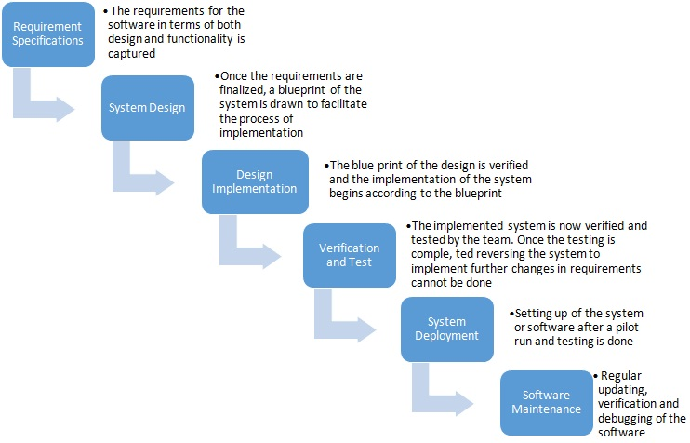**Fig 1.1 Waterfall model**

**User-Centred Design (UCD) Methodology**

User-Centred Design (UCD) methodology ensures that the platform is intuitive, user-friendly, and aligned with the needs of its diverse user base. It has the following principles:

**1. User Research and Personas:**

* Understanding the User Base: In-depth user research is conducted to gain insights into the preferences, and pain points of the technology enthusiast community. This research is important for the design process.
* Creating User Personas: User personas representing various user segments are crafted. These personas help the development team empathize with and design for different user needs.

2. **Usability Testing**

* **Continuous Feedback Loop:** Blogr.io prioritizes a continuous feedback loop with its users. To ensure that the platform meets user needs and remains user-friendly, regular usability testing sessions are conducted. During these sessions, potential users interact with prototypes or early versions of the platform. For instance, Blogr.io might create prototypes of new features, such as a simplified article editor, and invite users to test its usability.
* **Usability Testing Session**: Usability testing often involves sessions where participants use Blogr.io while their interactions are observed and recorded. This might include tasks like creating a new article, leaving comments, or navigating the platform.

**3. Accessibility Considerations**

**Inclusive Design:** Accessibility is a fundamental aspect of Blogr.io's design philosophy. The platform is committed to inclusive design principles, ensuring that individuals with diverse abilities can access and use the platform effectively. For example, Blogr.io follows practices such as providing alt text for images, ensuring keyboard navigation, and maintaining a strong colour contrast to aid users with visual impairments.

4. **Iterative Design Process**

* **Feedback Integration**: Blogr.io's design process is highly iterative. Feedback from users plays a crucial role in shaping the platform. For example, if users suggest improvements to the comment system for articles, Blogr.io's design team iterates on the comment interface to make it more user-friendly and engaging.

## 3.2 Requirements Analysis

The requirement analysis phase involves a researching of user needs, ensuring that Blogr.io caters to the diverse requirements for its users. User stories and use cases are formulated, detailing the expected functionality of the platform. Through rigorous requirements gathering, the specific features, user interactions, and system capabilities are identified, guiding subsequent development phases.

The following components were used to provide a detailed understanding of the how project requirements were collected and analysed: user needs assessment, user stories and use cases, functional requirements, non-functional requirements, alignment with project goals, scope definition

### 3.2.1. User Needs Assessment

The following research methodologies were employed:

1. **Surveys:** Online surveys were conducted to gather structured feedback from a diverse group of potential users. These surveys focused on identifying preferences, pain points, and feature requests.

2. **In-Depth Interviews:** In-depth interviews with technology enthusiasts were conducted to gain qualitative insights. These one-on-one interactions allowed for a deeper understanding of user motivations and expectations.

3. **Online Community Engagement:** Active participation in online tech enthusiast communities and forums provided an opportunity to engage with potential users directly. Conversations, discussions, and feedback in these communities were invaluable in shaping Blogr.io's features.

**Research Findings**

Takeaways from the user needs assessment include:

**1. Content Diversity:** Technology enthusiasts express a strong desire for a platform that accommodates a wide range of content types, including tutorials, reviews, and personal experiences.

**2. Collaboration Opportunities:** Users expressed a keen interest in collaborating on projects and addressing industry challenges collectively. They value platforms that foster a sense of community and mutual support.

**3. Accessibility and Inclusivity:** Accessibility emerged as a significant concern. Users emphasized the importance of a platform that is designed with inclusivity in mind, ensuring access for individuals with diverse abilities.

**4.Professional Growth:** Technology enthusiasts are eager to use Blogr.io not only for knowledge sharing but also for personal and professional growth. Features that facilitate skill enhancement and mentorship are highly anticipated.

**5. User Engagement Tools:** The research indicated a strong preference for user engagement tools such as liking, commenting, and following other users. These features contribute to a sense of belonging within the community.

### 3.2.2 User Stories and Use Cases

**a) User stories**

User stories are short, simple descriptions of a feature or functionality from an end-user's perspective. Each user story typically follows a specific format, often referred to as the "As a [user], I want [action] so that [benefit]" format. This format helps articulate who the user is, what action they want to perform, and the benefit or value they expect to derive from it. They serve as the basis for prioritizing and planning features and serve as a foundation for creating test cases and acceptance criteria.

The following are user stories for blogr.io:

1. **User Account Creation:**
   * As a new user, I want to sign up with my email so that I can create a Blogr.io account.
   * As a user, I want the option to sign up using my Google account for a quick and easy registration process.
2. **User Interaction with Content:**
   * As a user, I want to read the latest articles to stay updated with the latest tech trends.
   * As a user, I want to be able to read the most popular articles to discover high-quality content.
   * As a user, I want to read recommended articles based on my interests for a personalized experience.
3. **User Interaction with Content (Post-Account Creation):**
   * As a registered user, I want to be able to like articles that I find interesting.
   * As a registered user, I want to leave comments on articles to share my thoughts and engage with the community.
   * As a registered user, I want to save articles for future reading so that I can revisit them later.
4. **User Article Creation:**
   * As a user, I want to write and publish articles on Blogr.io to share my knowledge and insights with the community.
5. **User Personal Information Update:**
   * As a user, I want to update my name, skills, location, and workplace in my profile settings.
   * As a user, I want to easily access my account profile and edit my information with a few clicks.
   * As a user, I want to save the changes I make to my profile information.
6. **User Newsletter Subscription:**

* As a user, I want the option to subscribe to newsletters so that I can receive updates and content recommendations via email.

1. **User Follow Another User:**

* As a registered user, I want to be able to follow other users on Blogr.io to stay connected and receive updates on their latest articles and activities.

1. **User Dashboard:**

* As a registered user, I want to have my personal dashboard on Blogr.io where I can view key metrics such as the total number of views on my articles, the number of followers I have, and other relevant statistics about my account activity. This dashboard will provide me with valuable insights into my engagement and reach within the Blogr.io community, helping me understand the impact of my contributions

1. **Logging Out:**

* As a registered user, I want the ability to log out of my Blogr.io account securely and easily. This way, I can ensure the privacy and security of my account when I'm not using the platform. Upon clicking the "Log Out" button, I expect to be logged out and redirected to the login page.

1. **Deleting Account:**

* As a registered user, I want the option to delete my Blogr.io account if I decide to no longer use the platform. To delete my account, I should be able to access the account settings, find the "Delete Account" option, and follow a secure deletion process. Before my account is permanently deleted, I expect to receive a confirmation prompt to ensure that I intend to delete my account and understand the consequences. Upon confirmation, my account should be deleted, and all associated data removed from Blogr.io's database.

**b) Use Cases**

**Use Case 1**: User Account Creation

* **Alex**: New User
* **Preconditions**:
  + User is on the Blogr.io registration page.
* **Main Flow**:

1. User selects the "Sign Up" option.
2. User provides their email address and creates a password.
3. User clicks the "Create Account" button.
4. The system validates the email and password.
5. Upon successful validation, the system creates the user's account.
6. User is redirected to articles page

**Use Case 2: User Commenting**

* **Alex**: Logged-in User
* **Preconditions**:
  + User is logged into their Blogr.io account.
* **Main Flow**:
  + User navigates to an article.
  + User scrolls to the comments section.
  + User enters their comment in the text box.
  + User clicks the "Post Comment" button.
  + The system displays the user's comment.

### 3.2.3 Functional Requirements

**F**unctional requirements represent the core features and capabilities of the platform, ensuring that it effectively meets the needs and expectations of its users, who are enthusiastic about technology. Each feature description outlines its purpose, ensuring that the development process aligns with our user-focused approach.

The functions include:

**a) Account Management**

**Feature 1: User Account Creation**

* **Description:** Users should be able to create a Blogr.io account using their email address. This feature aims to provide a seamless onboarding experience for new users.
* **Requirements:**
  + The registration process should include email verification for security.
  + Password requirements (e.g., length, complexity) should be defined.

**b) Content Creation**

**Feature 2: Article Creation**

* **Description:** Users should be able to create, compose, and publish articles on Blogr.io, allowing them to contribute their expertise and experiences within the tech field.
* **Requirements:**
  + The article creation process should include text editing tools, image uploading capabilities, and formatting options.
  + Published articles should be accessible to the Blogr.io community.

**c) User Interactions**

**Feature 3: Liking Articles**

* **Description:** Users should have the ability to like articles, allowing them to express appreciation for content they find valuable.
* **Requirements:**
  + The platform should track and display the number of likes for each article.
  + Users should be able to like an article with a single click.

**Feature 4: Commenting on Articles**

* **Description:** Users should be able to engage in discussions by posting comments on articles.
* **Requirements:**
  + The comment section should be user-friendly and support rich text input.
  + Comments should be displayed in a threaded format for better readability.

### 3.2.4 Use of Personas

Personas shed light on how different people have influenced our decisions regarding feature priorities and design considerations, ensuring that Blogr.io caters comprehensively to the diverse requirements of its users.

**User Persona Example:** Aspiring Web Developer

**Name:** Alex

**Age:** 25

**Occupation:** Student and Part-Time Shopkeeper

**Background:** Alex is a recent computer science graduate with a passion for web development.

**Goals:**

* + Learn Web Development: Alex's primary goal is to become a proficient web developer. He is eager to acquire coding skills, work on real projects, and gain hands-on experience.
  + Share Learning Journey: Alex is enthusiastic about sharing their journey of learning web development, documenting challenges, and celebrating successes with the online community.
  + Network with Professionals: Alex hopes to connect with experienced web developers, learn from their expertise, and build a professional network

**Pain Points:**

* Limited Coding Experience: Being relatively new to web development, Alex faces challenges related to coding complexity and uncertainty about best practices.
* Time Constraints: Juggling coursework and a part-time job leaves Alex with limited time to dedicate to his web development journey.
* Need for Guidance: Alex seeks guidance on choosing the right technologies, project ideas, and effective learning resources.

This persona represents an essential case of Blogr.io's user base—an aspiring web developer who is eager to learn, share experiences, and connect with the tech community. Blogr.io's user-centred design ensures that Alex's needs are addressed, whether it's through accessible content, learning resources, or networking opportunities.

## 3.3 Design Phase

**1. System Architecture**

Tech Stack Selection:

* **Frontend:** Blogr.io's user interface will be built using React for its flexibility and interactivity, with Tailwind CSS for efficient styling.
* **Backend**: Node.js will power the backend server, with Express.js as a web application framework.
* **Database**: MongoDB will be used as the database system, and Mongoose will provide object data modeling for interacting with MongoDB.
* **Security**: User passwords will be securely hashed using bcrypt, and authentication will be managed with JSON Web Tokens (JWT).

**2. Database Schema Design**

* **User Schema**:

Fields: username, email, password (hashed), profile picture, biography, skills, education, location, work, technology, metadata.

const userSchema = mongoose.Schema(

  {

    name: {

**type**: String,

    },

    username: {

**type**: String,

      // required: true,

    },

    email: {

**type**: String,

      // required: true,

    },

    password: {

**type**: String,

      // required: true,

    },

    profileImage: {

**type**: String,

    },

    bio: {

**type**: String,

    },

    blogs: {

**type**: mongoose.Schema.Types.ObjectId,

      ref: "Blog"

    }

  },

  { timestamps: true }

);

const userModel = mongoose.model("User", userSchema);

* **Article Schema:**

Fields: title, cover image, author information, content, category, publication date.

const articleSchema = mongoose.Schema(

  {

    coverImage: {

**type**: String,

      required: true

    },

    title: {

**type**: String,

      required: [true, "Title is required"],

    },

    summary: {

**type**: String

    },

    categories: {

**type**: Array,

      required: [true, "At least one category is required"],

    },

    content: {

**type**: String,

      required: true,

    },

    author: {

**type**: mongoose.Schema.Types.ObjectId,

      ref: 'User'

    }

  },

  { timestamps: true }

);

const articleModal = mongoose.model('Blog', articleSchema);

* **Comment Schema:**

Fields: commenter, article reference, content, timestamp.

const commentsSchema = mongoose.Schema(

  {

    comment: {

**type**: String,

    },

    articleId:{

**type**: String

    },

    author: {

**type**: mongoose.Schema.Types.ObjectId,

      ref: 'User',

    },

  },

  { timestamps: true }

);

const commentModel = mongoose.model("Comment", commentsSchema);

**3. Application Program Interface(API) Development**

An **application programming interface** (**API**) is code that enables two software programs to communicate.

* **API Bridge:** An API layer will be created as a bridge between the frontend and backend. This API will define endpoints for frontend interactions with the backend, ensuring data retrieval and manipulation. It will facilitate communication and data exchange.
* **Routing:** Express.js will be used for routing, defining routes and their corresponding functionalities.
* **Middleware:** Middleware functions will be implemented for tasks like authentication, error handling, and data validation.

**4. Redux Toolkit and Redux Toolkit Query**

* **State Management:** Redux Toolkit will be employed for state management on the frontend. It will handle complex application states, including user authentication and data storage.
* **API Management:** Redux Toolkit Query will be used to manage API calls, enabling efficient data fetching and caching. It streamlines the integration of API endpoints with the Redux store.

**5. System Architecture Image**

This image shows the relationship between the client, server and the database

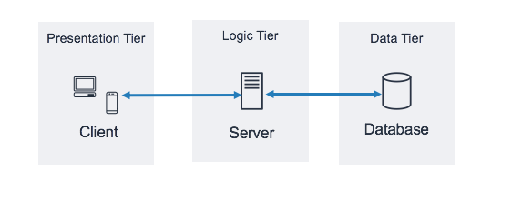

## 3.4 Development Phase

In the development phase, design plans are translated into functional code, integrating the frontend and backend technologies. This phase focuses on the actual implementation of key platform functionalities, emphasizing modularity and maintainability for future enhancements.

**1. Frontend Development**

* **React Components:** Individual React components will be developed for various parts of the user interface, ensuring modularity and reusability.
* **Redux Integration:** Integration of Redux Toolkit for managing state, including user authentication, content, and user interactions and Redus Toolkit Query for handling API calls.
* **User Interface Styling**: Implementation of the user interface design using Tailwind CSS, creating a visually appealing and responsive platform**.**

**2. Backend Development**

* **Controllers:** They are developed to handle the logic behind each route. Controllers serve as the bridge between the routes and the database, ensuring that the requested actions are executed correctly. They manage data retrieval, processing, and responses.
* **Express Routes:** Development of Express.js routes to handle API requests and responses for account management, article creation, comments, and other functionalities.
* **MongoDB Integration:** Integration of MongoDB and Mongoose for database operations, ensuring seamless data storage and retrieval.
* **Middleware:** Implementation of middleware functions for authentication, error handling, and data validation.

**6. Modular Code Structure**

* **Modular Approach:** Code is organized into modules for better maintainability and scalability.
* **Code Documentation:** Codebase is documented to facilitate future development and collaboration.

## 3.5 Testing and Quality Assurance

It involves various testing procedures and quality control measures to ensure the platform's reliability, security, and performance meet industry standards and user expectations.

The testing procedures include:

1. **Functional Testing:** Functional testing is conducted to verify that each feature and functionality of Blogr.io works as intended. It involves rigorous testing of user interactions, data processing, and system behavior. Functional tests are performed at both the frontend and backend levels**.**
2. **Performance Testing:** Performance testing evaluates the platform's responsiveness and scalability. It assesses how Blogr.io handles various loads and usage scenarios. Performance tests help optimize the system to ensure it can accommodate a growing user base without compromising speed and reliability.
3. **Iterative Testing:** Testing and quality assurance are iterative processes throughout the development lifecycle. As new features are implemented and changes occur, testing is repeated to verify that the entire system remains robust and reliable

## 3.6 Maintenance

The Maintenance phase is a continuous and essential aspect of Blogr.io's lifecycle. It involves activities aimed at ensuring the platform's sustainability, performance, and alignment with user expectations.

# CHAPTER FOUR

## 4.0 Findings, Data Analysis, Conclusions and Recommendations

## 4.1 Findings

### 4.1.1 User Engagement Insights

* Users actively engage with tutorials, indicating a strong interest in educational content.
* Comments and discussions are more prevalent in the blog section, fostering a sense of community.

### 4.1.2 Performance Discoveries

* The platform experiences peak usage during evenings and weekends.
* Load times for multimedia content need improvement.
* Some users encountered challenges with the password reset process.

## 4.2 Data Analysis

### 4.2.1 User Behavior Patterns

* Identify the most popular content categories based on views and likes.
* Correlate user demographics with content preferences.

### 4.2.2 Content Analytics

* Analyze content creation patterns, including the frequency of tutorials, reviews, and blogs.
* Track user interactions, such as likes, comments, and shares, for specific articles.
* Examine the impact of user recommendations on content visibility.

## 4.3 Conclusions

### 4.3.1 Platform Successes

* Blogr.io successfully centralizes technology-related content, reducing fragmentation.
* The user-friendly onboarding process encourages active participation.
* User-generated recommendations enhance content discoverability and engagement.

### 4.3.2 Challenges Acknowledged

* Performance issues related to multimedia content loading require attention.
* Password reset challenges need streamlining for a smoother user experience.

## 4.4 Recommendations

### 4.4.1 Feature Enhancement

* Improve multimedia content loading times to enhance user experience.
* Streamline the password reset process for user convenience.
* Implement a content recommendation algorithm to further enhance discoverability.

### 4.4.2 User Retention Strategies

* Launch targeted email campaigns to re-engage inactive users.
* Create a dedicated mobile app for greater accessibility.

### 4.4.3 Content Promotion

* Develop a social media sharing feature to increase content visibility.
* Establish partnerships with technology influencers for content promotion.
* Launch themed content events to boost engagement during specific periods.

### 4.4.4 Future Expansion

* Explore the possibility of expanding into related tech fields based on user feedback.
* Continuously monitor and address emerging technology trends.
* Prioritize regular maintenance and updates to ensure long-term success.

# References

**1.** System architecture image: [System Architecture](https://docs.aws.amazon.com/images/whitepapers/latest/serverless-multi-tier-architectures-api-gateway-lambda/images/image2.png)

2.Waterfall model image: [Waterfall Model](https://www.mbaskool.com/2013_images/stories/dec_images/bcon-waterfall.jpg)

3.History of Internet: [History of Internet](https://en.wikipedia.org/wiki/History_of_the_Internet)

4.Bulletin Board System: [Bulletin Board System](https://en.wikipedia.org/wiki/Bulletin_board_system)

5.Community of Practice: [Community of Practice](https://en.wikipedia.org/wiki/Community_of_practice)

6.User Generated Content: [User Generated Content](https://blog.hootsuite.com/user-generated-content-ugc/#:~:text=User%2Dgenerated%20content%20(also%20known,testimonial%2C%20or%20even%20a%20podcast.&text=%22Words%20are%20only%20one%20form%20of%20communication.)

7.Social Capital: [Social Capital](https://www.ncbi.nlm.nih.gov/pmc/articles/PMC7599811/#:~:text=Bourdieu%20defined%20social%20capital%20as,and%20recognition%E2%80%9D%20%5B25%5D.)

# PROJECT SCREENSHOTS

**1.**Home page



2. Articles Page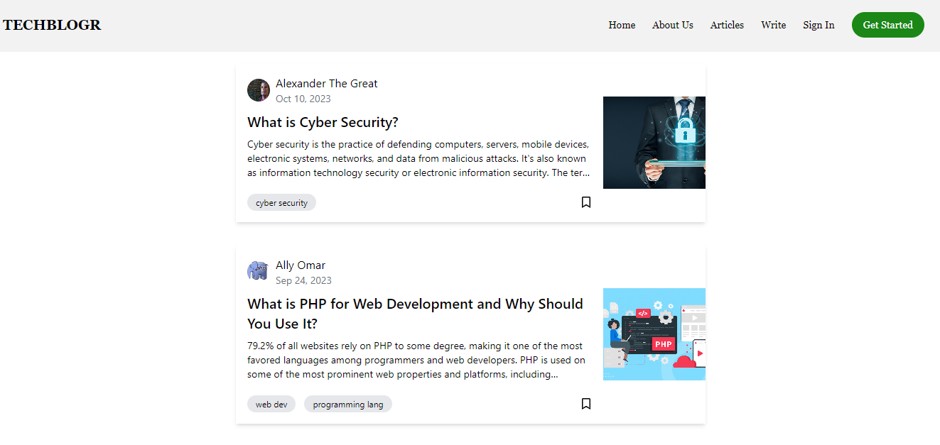

3.Sign Up Page

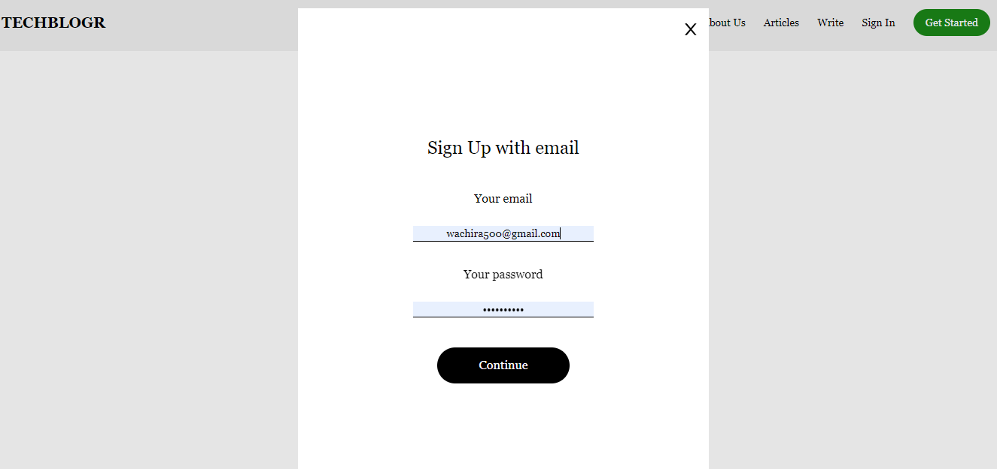

1. Publish Article Page

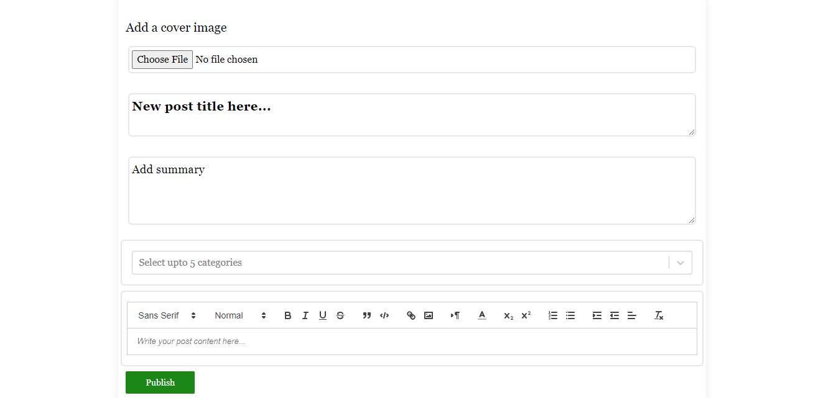

1. User Account Page

